Flask+MySQL实现前后台交互
- 项目结构
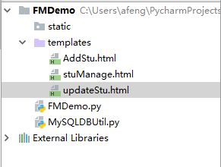

- 建表
CREATE TABLE stu (
s_id int(11) NOT NULL auto_increment,
s_name varchar(50) NOT NULL,
s_address varchar(60) DEFAULT '北京昌平',
PRIMARY KEY (s_id)
) ENGINE=InnoDB DEFAULT CHARSET=utf8;

三、在表中插入数据
INSERT INTO stu (s_name,s_address)
VALUES('李萍', '北京海淀'),('刘华', '上海黄浦区'),
( '黄骅', '深圳皇岗'),
('李娟', '中国西藏');

四、在pycharm中创建Flask工程
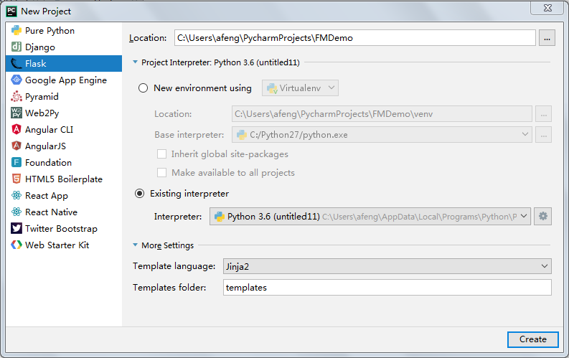

五、编写Python访问MySQL的封装类
# encoding=utf-8
# 1、导入模块
import pymysql
class PyMySQL():
# 初始化，获取连接对象
def __init__(self, host="127.0.0.1", port=3306, user="root", passwd="root", db="czf2", charset='utf8'):
self.host = host
self.port = port
self.user = user
self.passwd = passwd
self.db = db
self.charset = charset
self.conn = pymysql.connect(host=host, port=int(port), user=user, passwd=passwd, db=db, charset=charset)
# 返回连接对象
def getConn(self):
return self.conn
# 返回游标
def getCursor(self):
self.cursor = self.conn.cursor()
return self.cursor
# 查询出一个数据
def getOneData(self, sql,param=None):
cursor = self.conn.cursor()
cursor.execute(sql,param)
row = cursor.fetchone();
cursor.close()
return row
# 查询出数据集
def getManyData(self, sql,param=None):
cursor = self.conn.cursor()
cursor.execute(sql,param)
row = cursor.fetchall();
cursor.close()
return row
# 非查询操作:添加、删除、修改
def noQury(self, sql,param=None):
mark = False
cursor = self.conn.cursor()
cursor.execute(sql,param)
try:
self.conn.commit()
mark = True
except Exception as e:
self.conn.rollback()
finally:
cursor.close()
return mark
# 关闭连接
def closeAll(self):
self.conn.close()
# 销毁对象时，关闭连接
def __del__(self):
self.closeAll()

- 前端页面
stuManage.html
<!DOCTYPE html>
<html lang="en">
<head>
<meta charset="UTF-8">
<title>修改学生</title>
</head>
<body>
<form action="update" method="get">
<table>
<tr>
<td>请输入学生的ID</td>
<td><input type="text" value={{stu[0]}} name="stu_id" readonly/></td>
</tr>
<tr>
<td>请输入学生的姓名</td>
<td><input type="text" value={{stu[1]}} name="stu_name" /></td>
</tr>
<tr>
<td>请输入学生的地址</td>
<td><input type="text" value={{stu[2]}} name="stu_address" /></td>
</tr>
<tr>
<td></td>
<td><input type="submit" value="修改"/></td>
</tr>
</table>
</form>
</body>
</html>

AddStu.html
<!DOCTYPE html>
<html lang="en">
<head>
<meta charset="UTF-8">
<title>添加学生</title>
</head>
<body>
<form action="add" method="get">
<table>
<tr>
<td>请输入学生的姓名</td>
<td><input type="text" name="stu_name"/></td>
</tr>
<tr>
<td>请输入学生的地址</td>
<td><input type="text" name="stu_address"/></td>
</tr>
<tr>
<td></td>
<td><input type="submit" value="添加"/></td>
</tr>
</table>
</form>
</body>
</html>
updateStu.html
<!DOCTYPE html>
<html lang="en">
<head>
<meta charset="UTF-8">
<title>修改学生</title>
</head>
<body>
<form action="update" method="get">
<table>
<tr>
<td>请输入学生的ID</td>
<td><input type="text" value={{stu[0]}} name="stu_id" readonly/></td>
</tr>
<tr>
<td>请输入学生的姓名</td>
<td><input type="text" value={{stu[1]}} name="stu_name" /></td>
</tr>
<tr>
<td>请输入学生的地址</td>
<td><input type="text" value={{stu[2]}} name="stu_address" /></td>
</tr>
<tr>
<td></td>
<td><input type="submit" value="修改"/></td>
</tr>
</table>
</form>
</body>
</html>

- 后台代码

from flask import Flask,render_template,url_for,request,redirect
from MySQLDBUtil import *
app = Flask(__name__)
mysql= PyMySQL()
#查询所有学生的信息
@app.route('/')
def getAll():
row=mysql.getManyData("select * from stu")
return render_template("stuManage.html",stus=row)
#添加一个学生
@app.route('/addPage')
def toAddPage():
return render_template("AddStu.html")
@app.route('/add')
def addStu():
name=request.values.get('stu_name')
address=request.values.get('stu_address')
f=mysql.noQury("insert into stu(s_name,s_address) values(%s,%s)",(name,address))
if f:
return redirect(url_for('getAll'))
else:
return render_template("AddStu.html")
#删除一个学生
@app.route("/deleteByID")
def deleteByID():
id=request.args['sid']
id=int(id)
f=mysql.noQury("delete from stu where s_id=%s",(id))
if f:
return redirect(url_for('getAll'))
else:
return render_template("stuManage.html")
#修改一个学生
@app.route("/getUpdateStu")
def GetUpdatedStuById():
sid=request.values.get("sid")
s=mysql.getOneData("select * from stu where s_id=%s",(sid))
return render_template("updateStu.html",stu=s)
@app.route("/update")
def update():
sid=request.values.get("stu_id")
sname=request.values.get("stu_name")
saddress=request.values.get("stu_address")
print(sid,sname,saddress)
f=mysql.noQury("update stu set s_name=%s,s_address=%s where s_id=%s",(sname,saddress,sid))
if f:
return redirect(url_for('getAll'))
else:
return render_template("updateStu.html")
if __name__ == '__main__':
app.run(debug=True)

实例2
上面的例子比较简单，表单里也只包含text和提交，数据库也只有单张表，下面做一个稍微复杂的系统。

- 业务需求
- 单选框、下拉列表、多选框的处理
- 图片文件的上传和删除
- 主外关系的处理
- Flask和MySQL的前后台数据交互（CRUD）

- 建表
学生：包含id,name,age,gradeid，picture,hobby,sex
年级：gradeid,gradename

use czf2;
create table grade(
id int primary key auto_increment,
name varchar(40) not null
);
insert into grade(name) values("s1"),("s2"),("s3"),("s4");
select * from grade;
drop table stu_table;

create table stu_table(
id int primary key auto_increment,
name varchar(40) not null,
age int(3) not null,
gradeid int,
picture varchar(60) not null,
hobby varchar(80) not null,
sex varchar(10) not null,
foreign key(gradeid) references grade(id)
);

insert into stu_table(name,age,gradeid,picture,hobby,sex)
values("陈丽",23,4,"imgs/1.jpg","游泳,爬山","女"),
("刘华",18,3,"imgs/2.jpg","游泳,读书,阅读","男"),
("王丽",20,2,"imgs/3.jpg","爬山,游戏","女"),
("王郝丽",19,1,"imgs/4.jpg","阅读,游戏","女");

select * from stu_table;

